# Cognizant Challenge

Create a web application for programming competition game. For this, you have to implement two pages:

1. A submission page, where a player writes his nickname, selects a task from list, writes code solution, and submits. For example, select a Fibonacci algorithm task and then write it in C#. You can describe how the test input will be taken in the description.

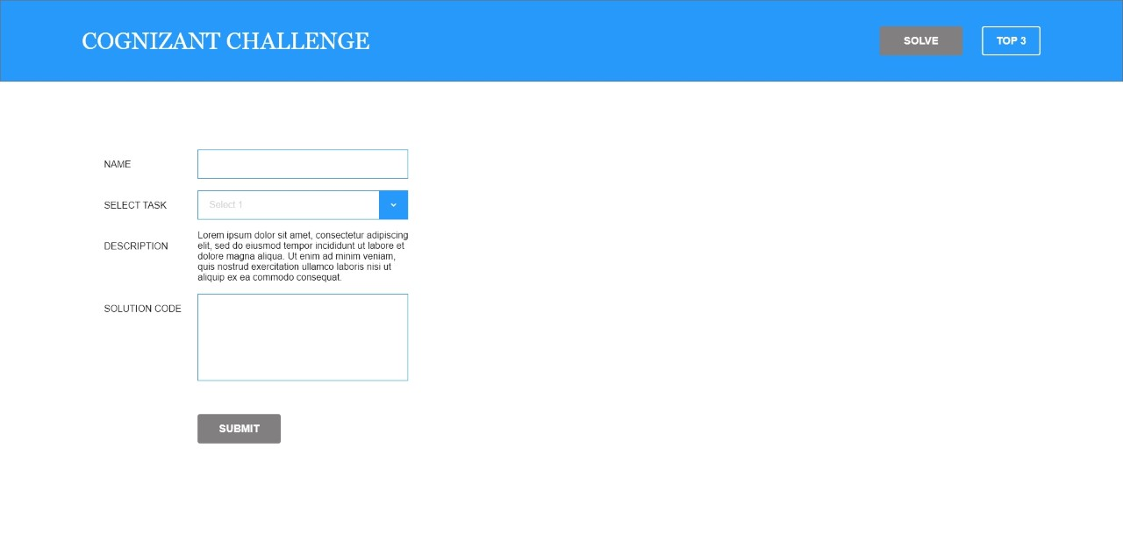

You can predefine tasks in DB with four columns: task name, description, test input parameter with which the solution code will be submitted (compiled and run) and output parameter with witch the submission output will be compared to determine success/failure. Preload the DB with a couple of example tasks.

2. Scores page with a table providing top 3 players with most successful submissions: player nickname, number of successful submissions, names of solved tasks.

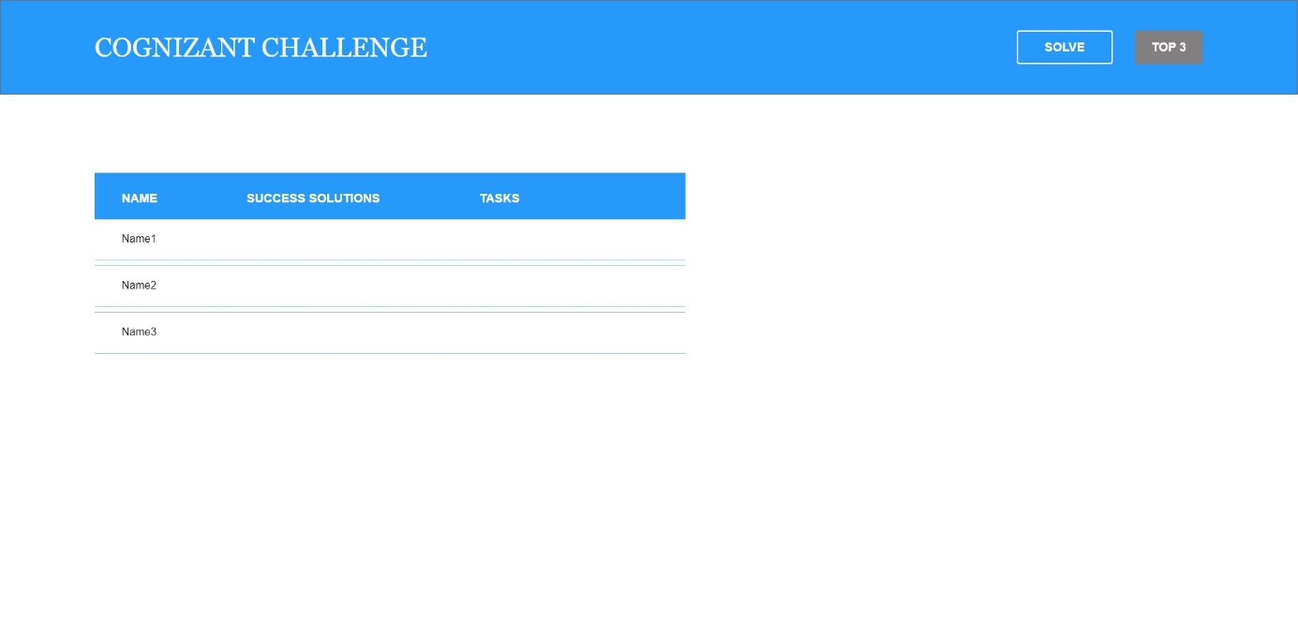

Hints:

1. You don't have to write your own compiler, you can use <https://rextester.com/main> or other online compiler API. It is enough to accept only one language – C#.

2. You don't have to implement authentication/login unless you have spare time for it. If not, just let the player to type his name.

3. It is enough to use a basic/default template. Just make it clean.

4. You have to develop the backend in C# (.Net Framework or .Net Core). You can choose a web technology (MVC or WebAPI + SPA) and DB on your own.

5. Feel free to use your creativity and make your own assumptions if something is unclear or just ask us :)